30th December 2021

Giant Christmas Card

Dear parents/carers,

This year, we have decided that we are going to have a giant Christmas card which will be available for children and staff to write a festive message in for a minimum donation of 50p. This will be instead of children handing out individual cards within school. By doing this, we are helping to reduce the spread of Covid-19 but also we are reducing the amount of paper waste within the school community. The card will be on display with the Christmas tree for all the children to see.
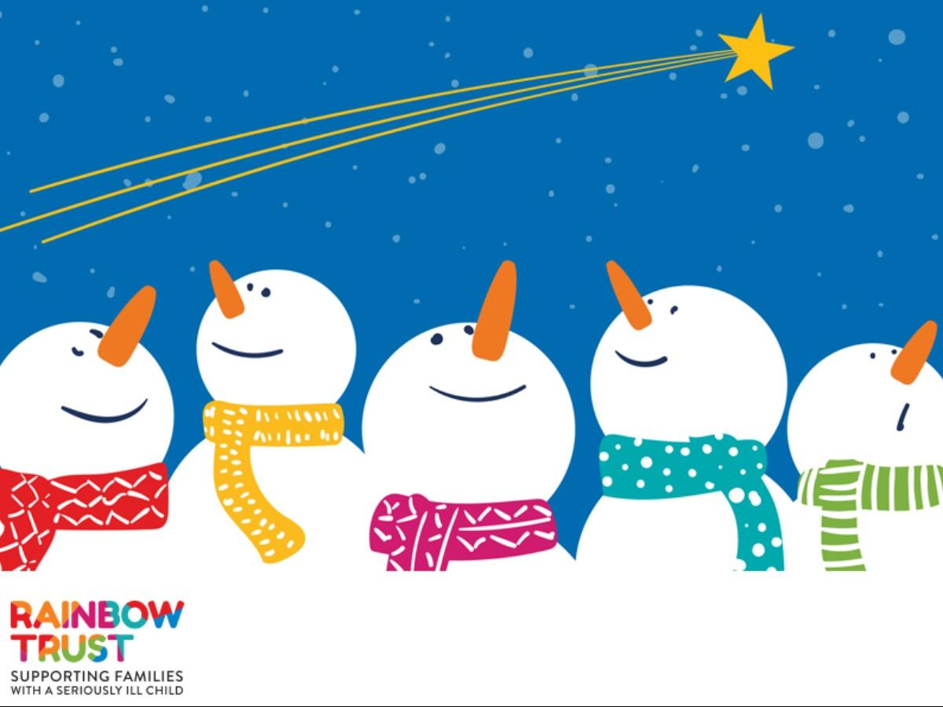

All donations raised from this will go to our chosen charity which is ‘Rainbow Trust’. Rainbow Trust support families with seriously ill children. This year, they are ‘Bringing the colour back this Christmas’ and helping families to spend lots of precious time together. Find out more about our chosen charity through these links:

https://www.rainbowtrust.org.uk/
https://youtu.be/E4PaYzcuB6E
https://youtu.be/nmYT-biCcps

The Christmas card will be available to sign during the week commencing 13th December, we will bring the card round for each class on a specific day so that all children will get the chance to sign it if they wish to do so.

 | Morning | Afternoon
Monday | Reception | Year 1
Tuesday | Year 2 | Year 3
Wednesday | Year 4 | Year 5
Thursday | Year 6 | Last sweep around whole school

Many thanks,

K.Marsh

