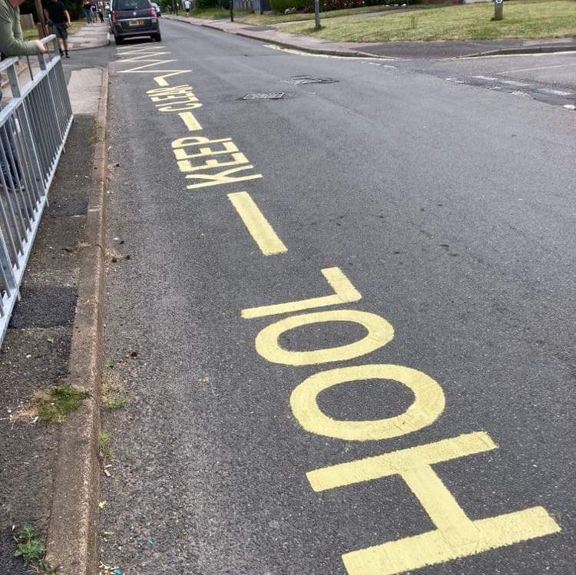
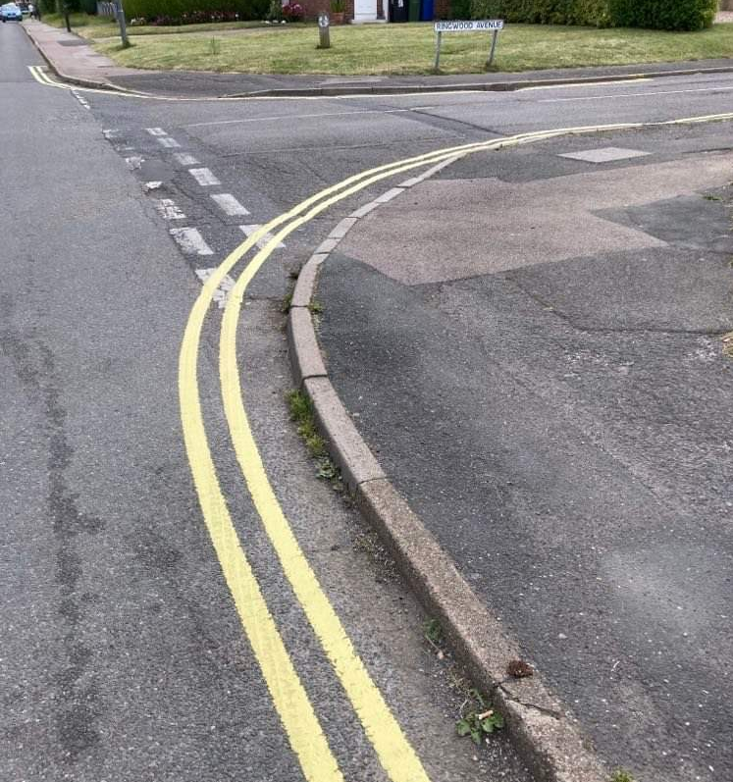
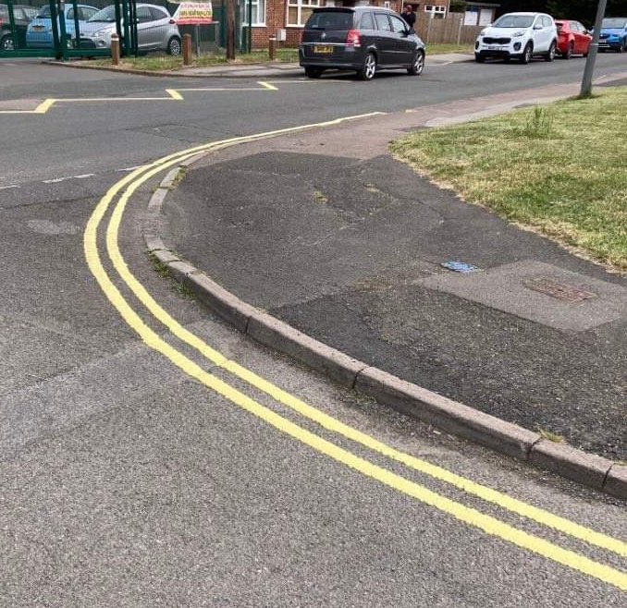

With the addition of our brand new double yellow lines across from the school gates, we would like to remind you that you should be parking legally and considerately around school at the start and end of the school day.

Taken directly from The Highway Code: section 243 (https://www.highwaycodeuk.co.uk/parking.html)
DO NOT stop or park
- near a school entrance
- anywhere you would prevent access for Emergency Services
- opposite or within 10 metres of a junction
- where the kerb has been lowered to help wheelchair users and powered mobility vehicles
- in front of an entrance to a property
- on a bend

Please can we remind you to be considerate of our neighbours and refrain from parking across driveways. Please also try to park on the same side of the road as other cars to create a clear access path. Whilst this is not a legal rule, it means that in an emergency, vehicles could easily get through – it will also mean the buses will be able to get through preventing a traffic build up.

